

Proximity Detector

*Utilizing an Ultrasonic Sensor*

Introduce an offboard sensor with a program that lights up the onboard LEDs to show how close an object is to a proximity detector (aka ultrasonic sensor).

MATERIALS:

|  |  |
| --- | --- |
| * CP Express (1) | * Breadboard (1) |
| * Ultrasonic sensor HC-SR04 (1) | * Alligator clips/pin wires (4) |

BUILD:

Schematic of the Circuit Playground Express connected to a breadboard and ultrasonic sensor. When wiring, pay close attention to GND (ground), Vout, and pins. Use alligator-pin clips or alligators with pin wires to connect to the breadboard.

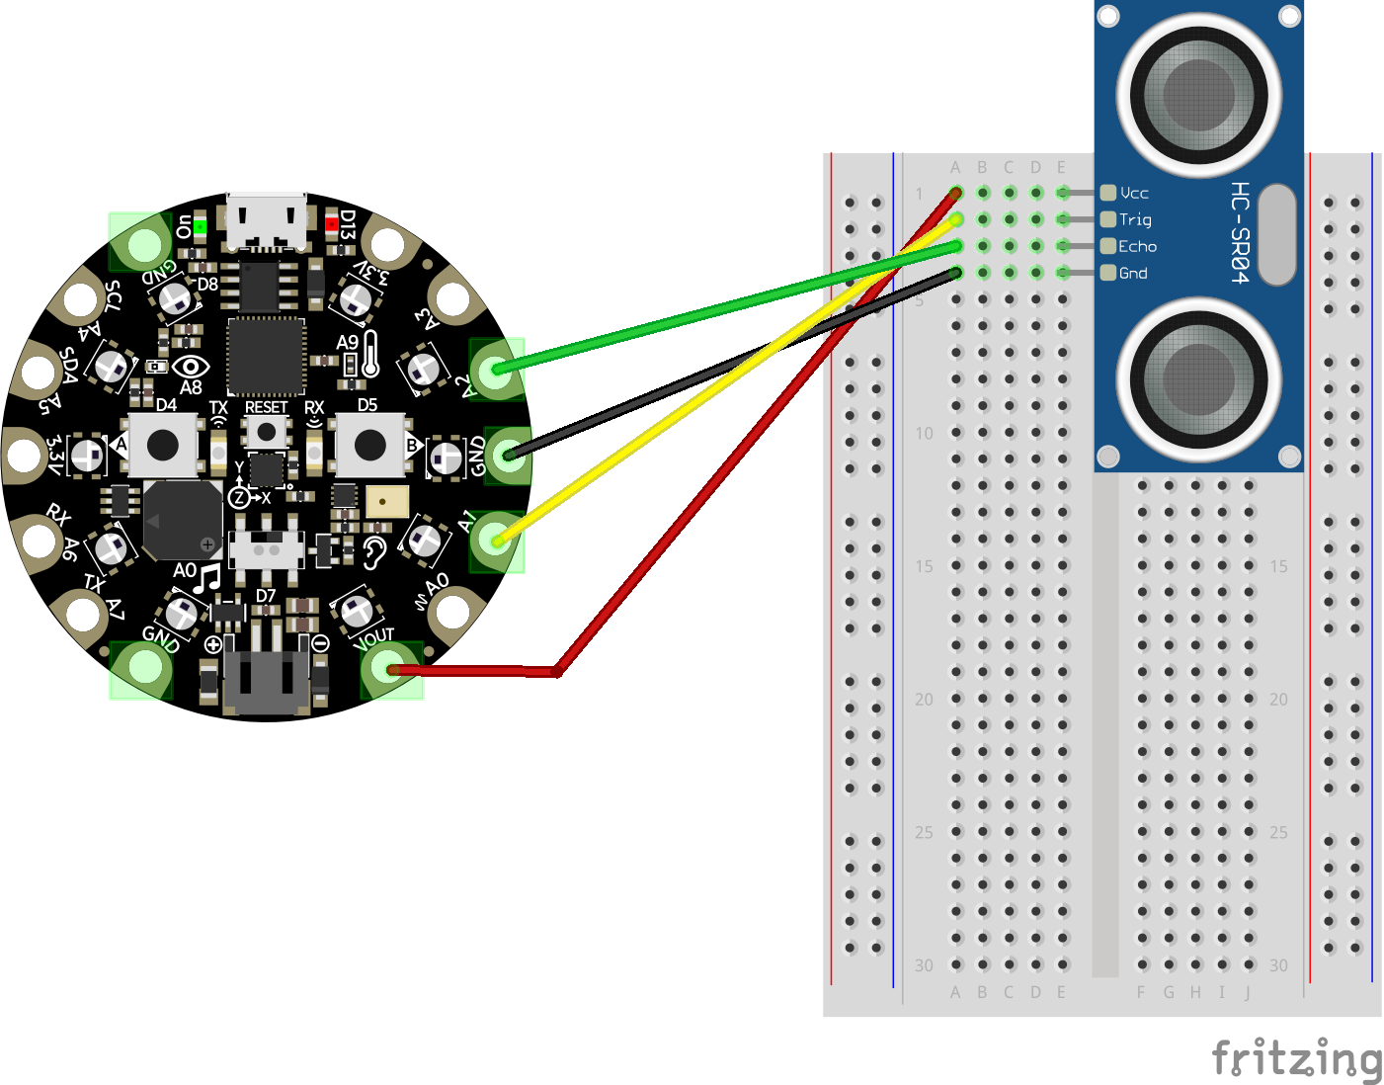

CODE:

